**Projects**

**1. Three Tier web application using docker and Kubernetes**

**1a) Three Tier web application using docker**

* **Sample Web application**

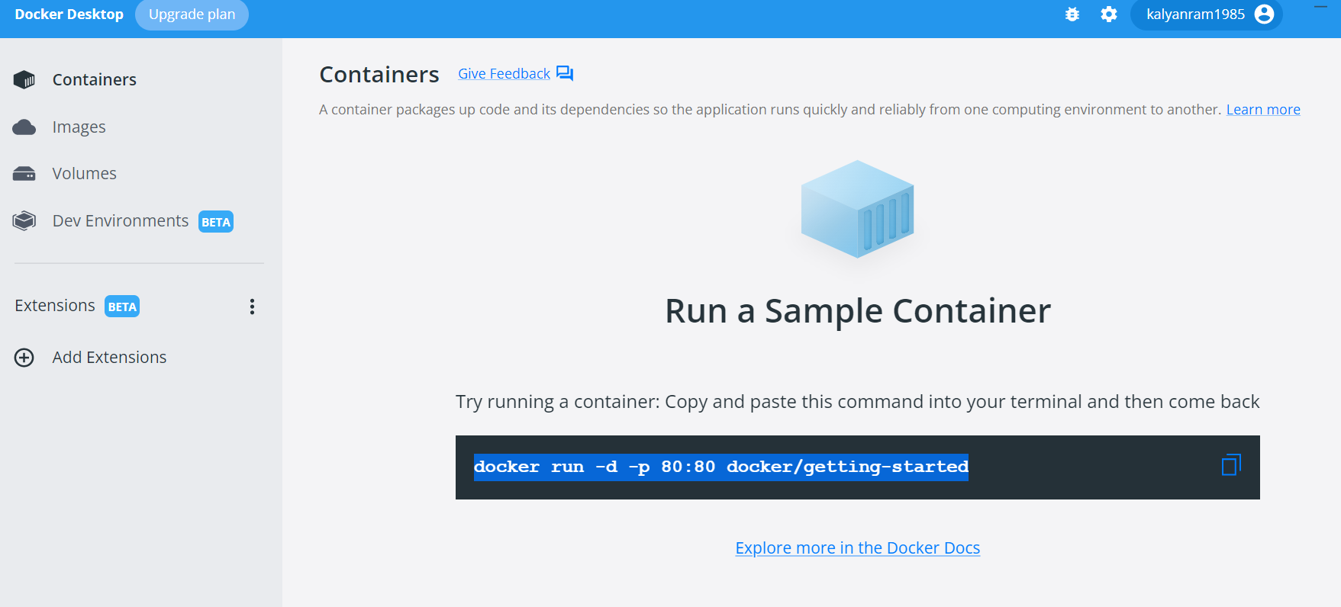

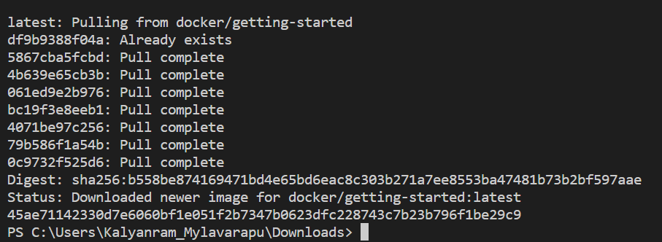

Download the App contents from the [getting-started repository](https://github.com/docker/getting-started/tree/master). You can either pull the entire project or [download it as a zip](https://github.com/docker/getting-started/archive/refs/heads/master.zip) and extract the app folder out to get started with.

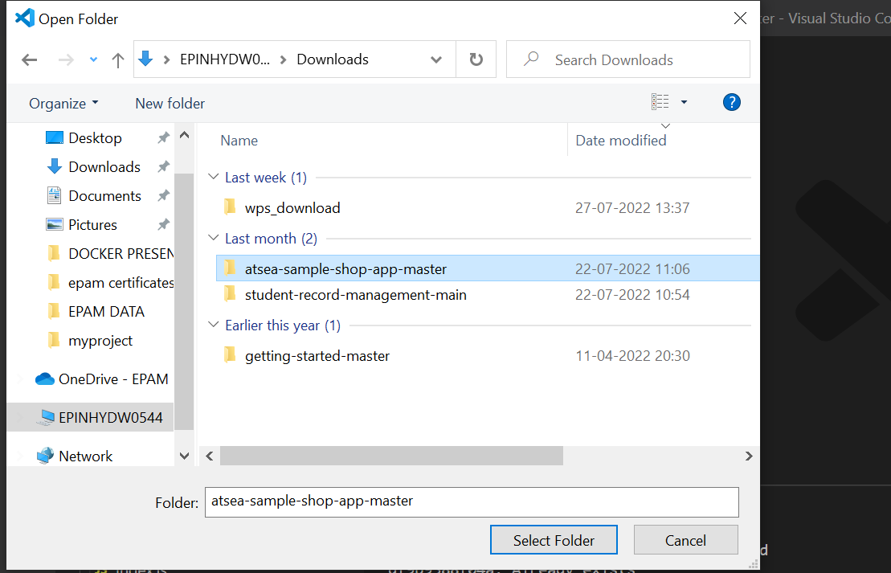

you can use [Visual Studio Code](https://code.visualstudio.com/). You should see the package.json and two subdirectories (src and spec).

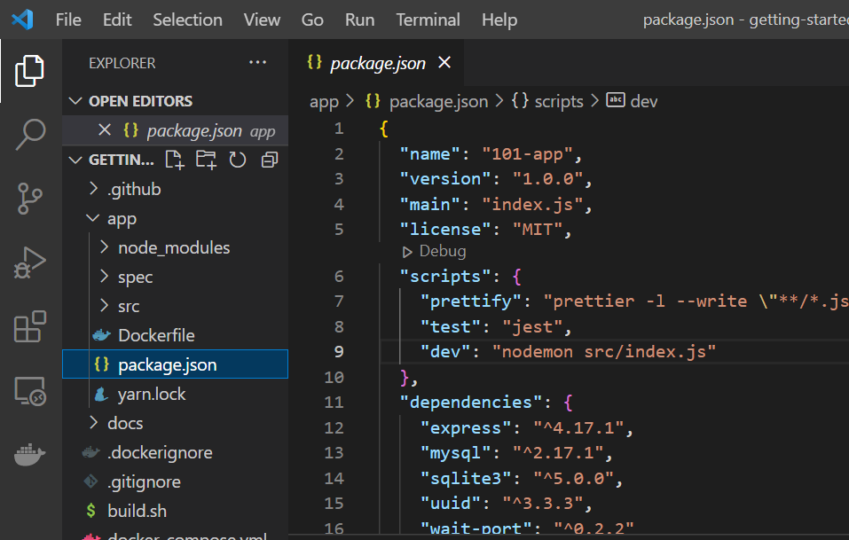

**Build the app’s container image**

We need to create a Docker file.

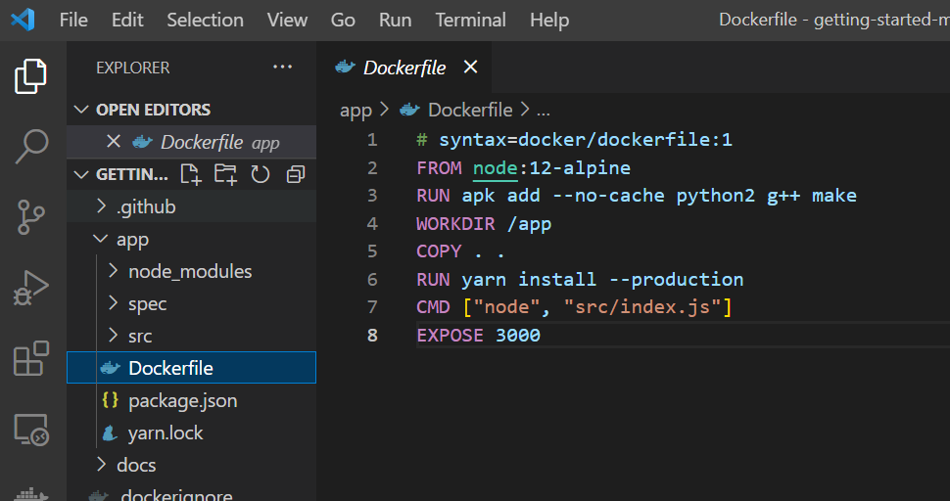



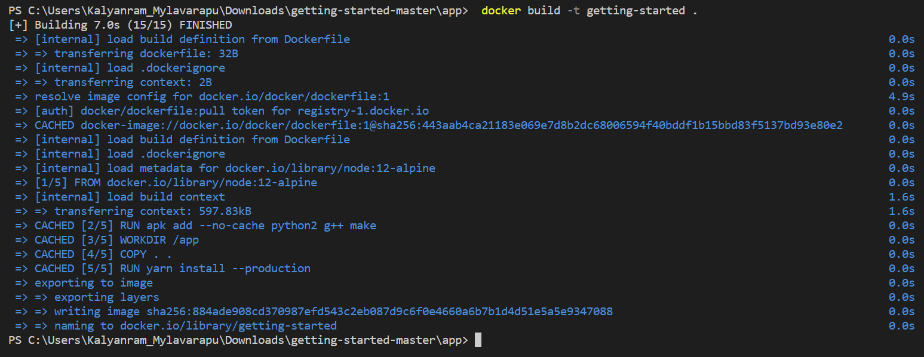

**Start an app container**

1. Start your container using the docker run command and specify the name of the image we just created:



2. After a few seconds, open your web browser to [http://localhost:3000](http://localhost:3000/). You should see our app.

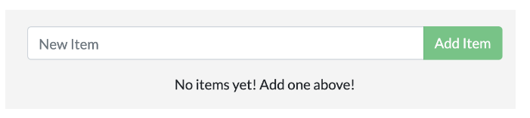

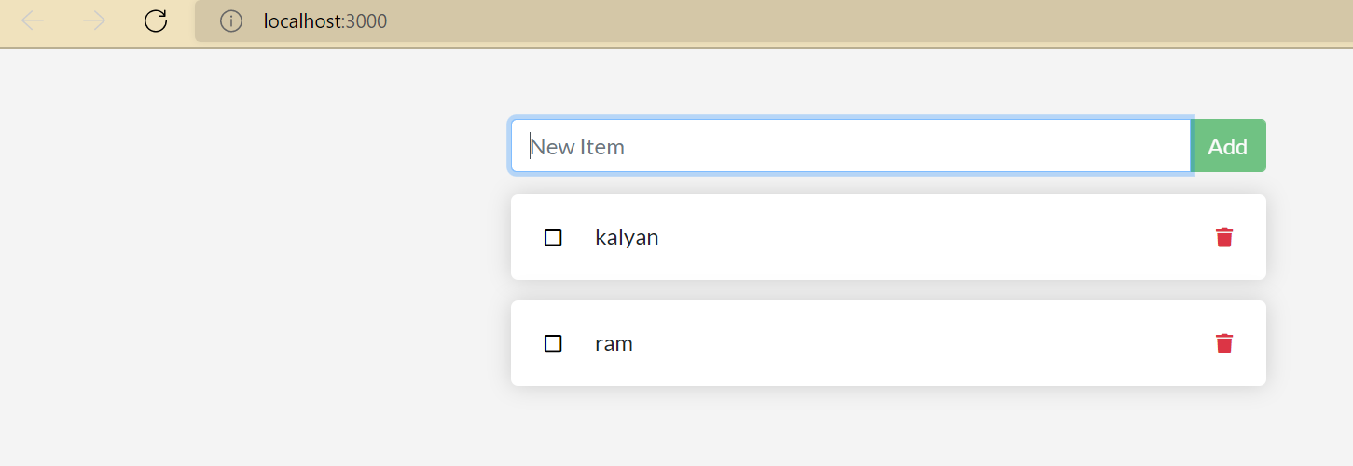

In above app, add an item or two and see that it works frontend is successfully storing items.

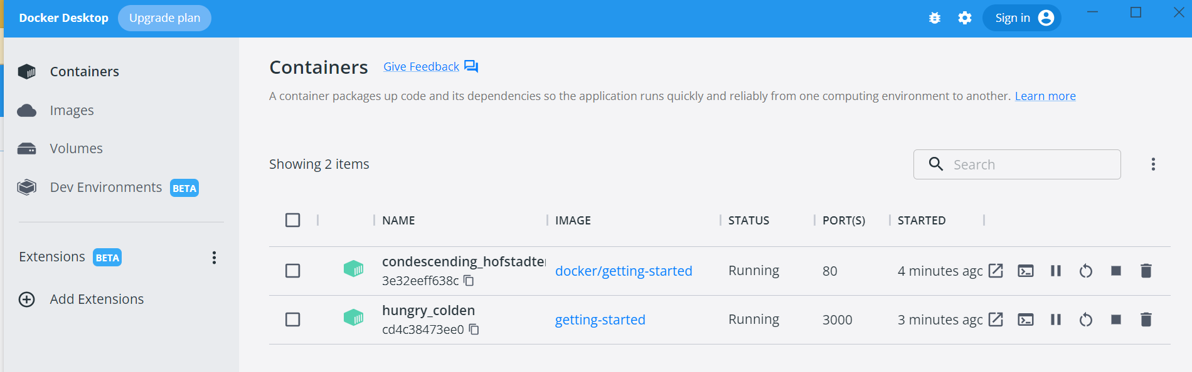

Docker Dashboard, you should see your two containers running

* **Update the application**

Update the source code

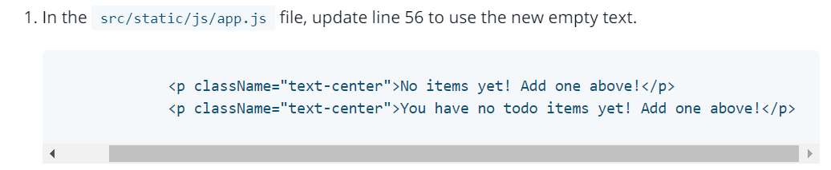

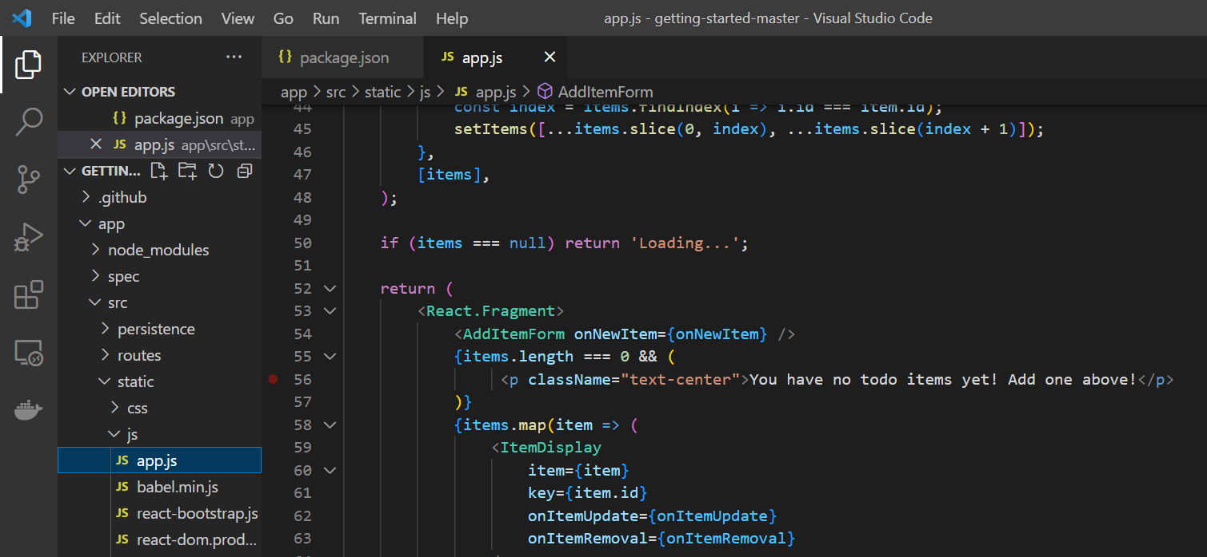

Remove a container using the CLI

Get the ID of the container by using the docker ps command.



Use the docker stop command to stop the container.



Once the container has stopped, you can remove it by using the docker rm command.



Now, start your updated app.



1. Refresh your browser on [http://localhost:3000](http://localhost:3000/) and you should see your updated help text!

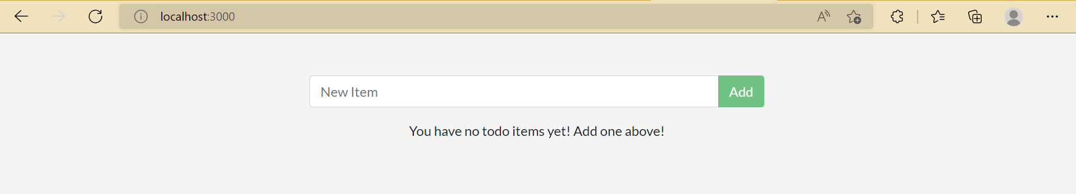

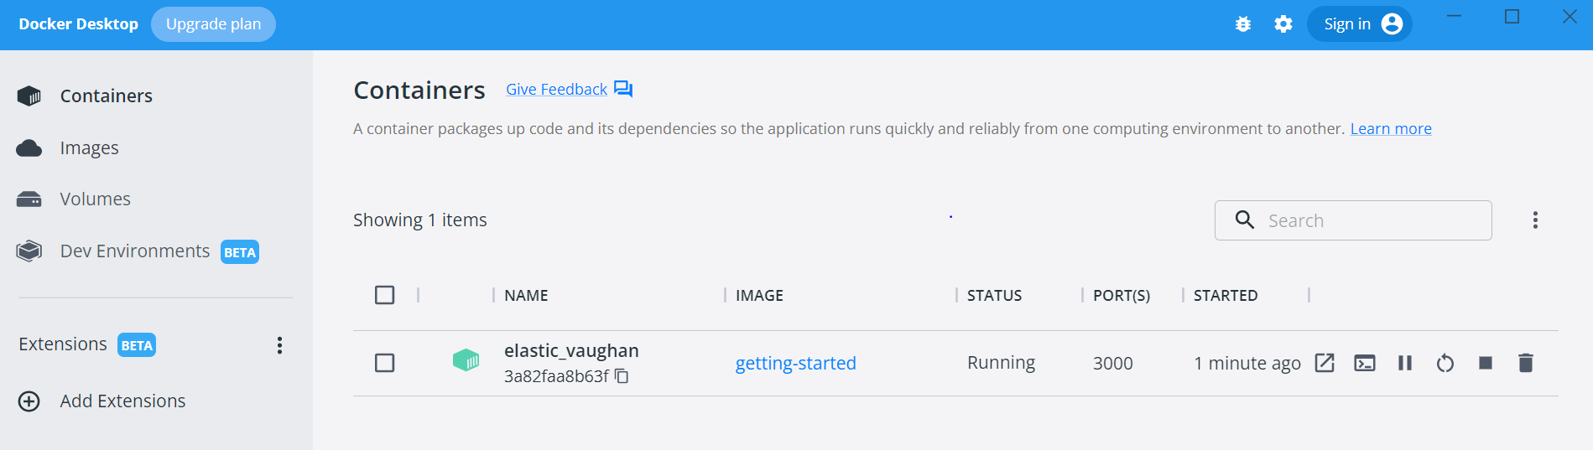

* **Share the application**

## Create a repo

1. [Sign up](https://www.docker.com/pricing?utm_source=docker&utm_medium=webreferral&utm_campaign=docs_driven_upgrade) or Sign in to [Docker Hub](https://hub.docker.com/).
2. Click the **Create Repository** button.

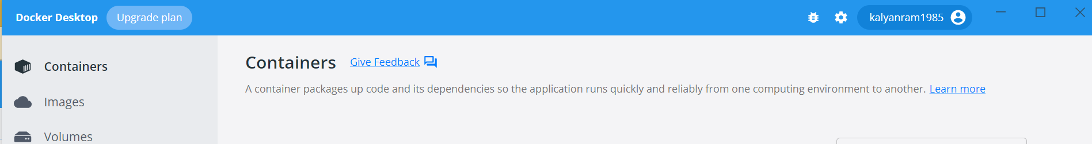

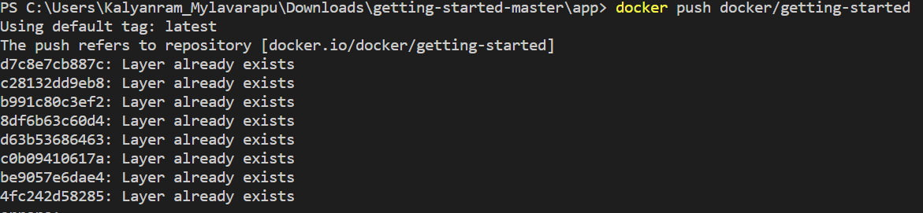

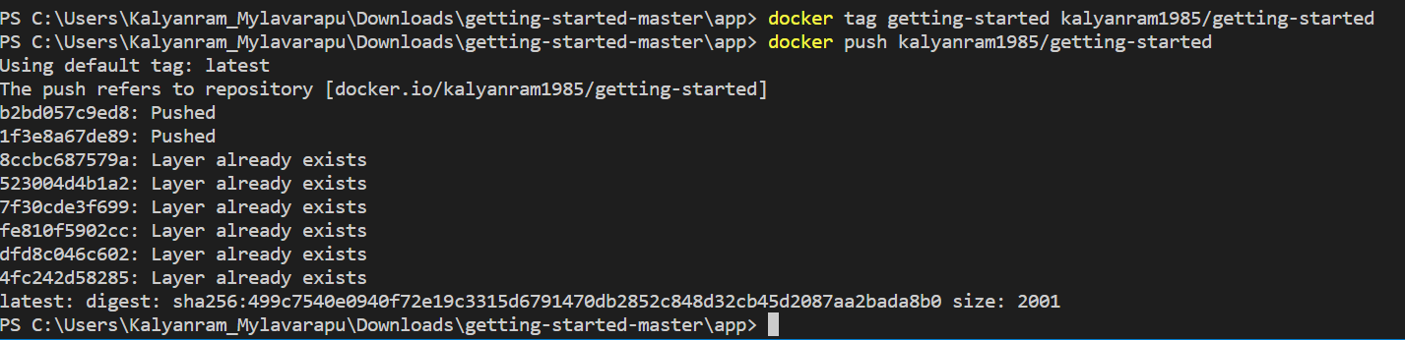

Run the image on a new instance

1. Open your browser to [Play with Docker](https://labs.play-with-docker.com/).
2. Click **Login** and then select **docker** from the drop-down list.
3. Connect with your Docker Hub account.
4. Once you’re logged in, click on the **ADD NEW INSTANCE** option on the left side bar. If you don’t see it, make your browser a little wider. After a few seconds, a terminal window opens in your browser.

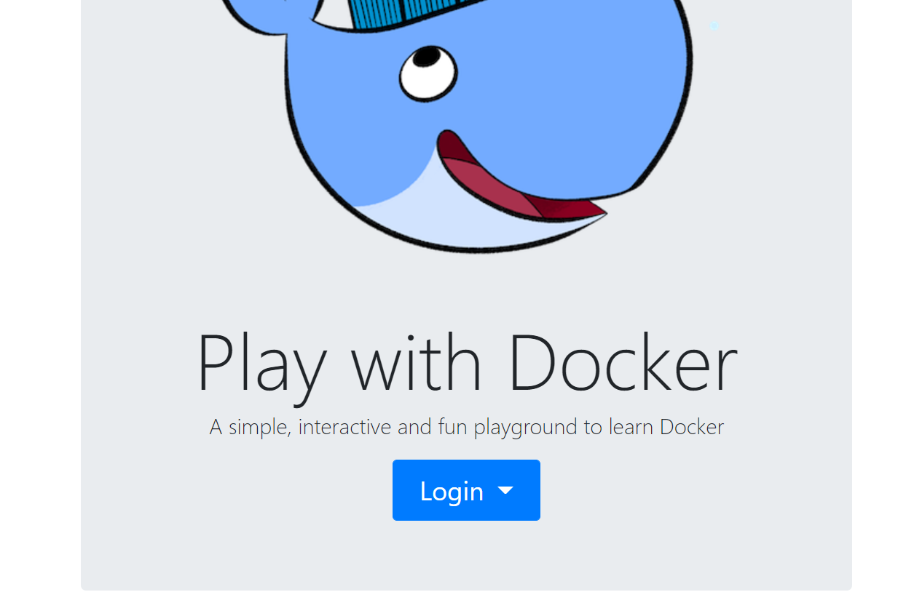

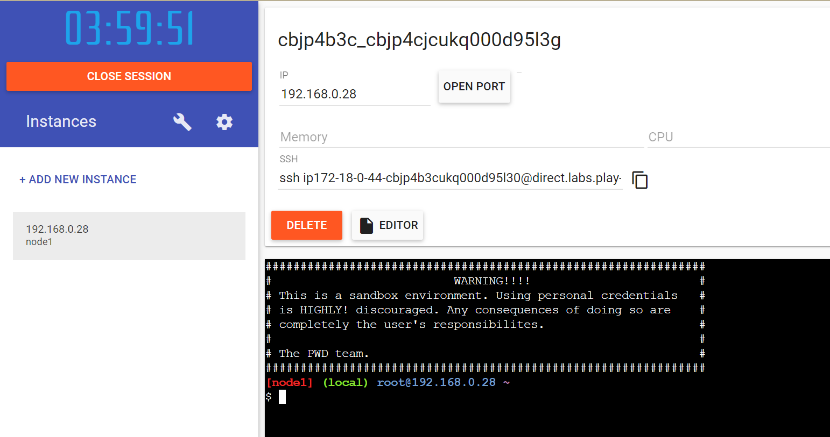

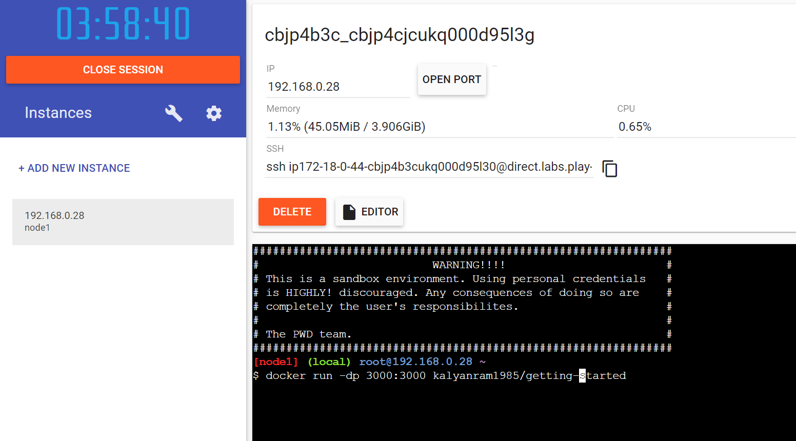

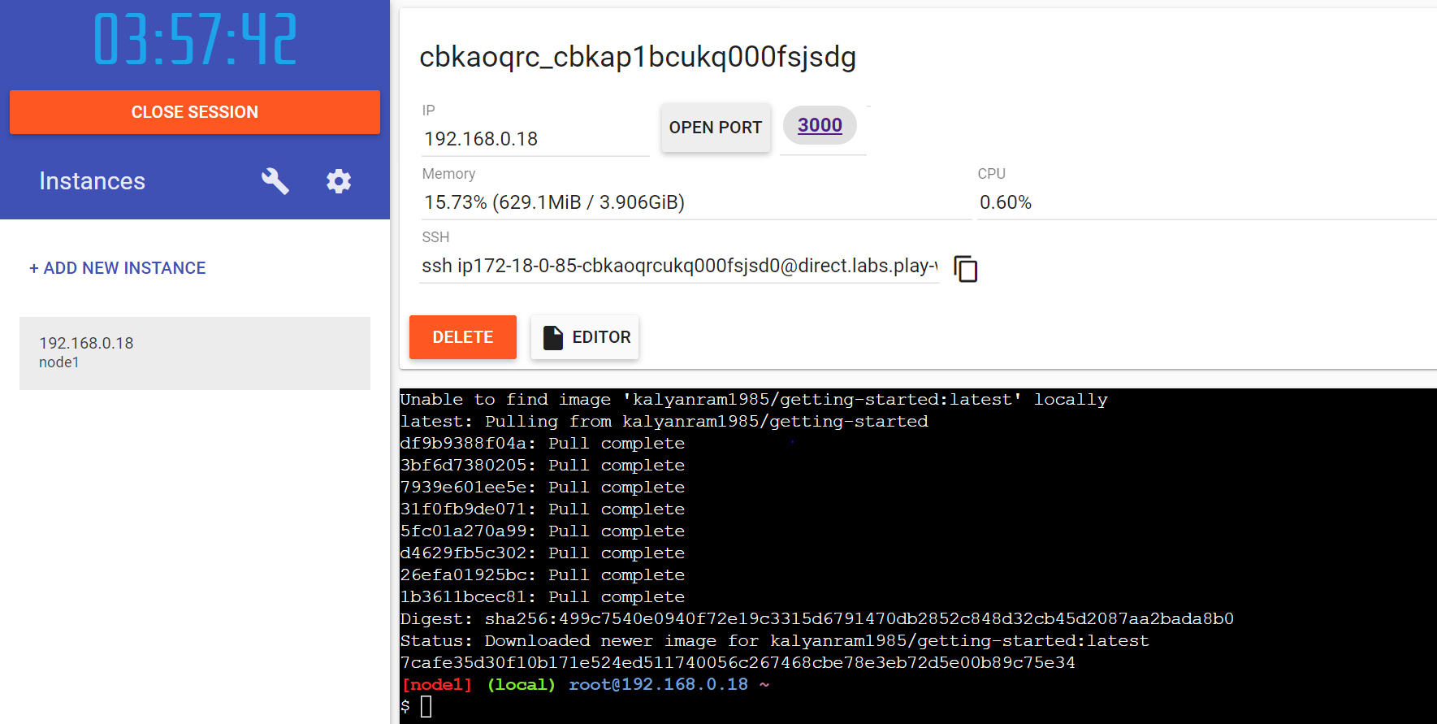

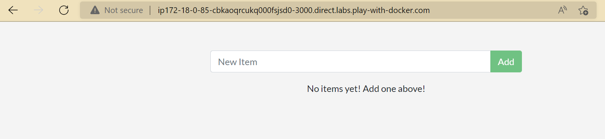

* **Persist the DB**

Start an ubuntu container that will create a file named /data.txt with a random number between 1 and 10000.



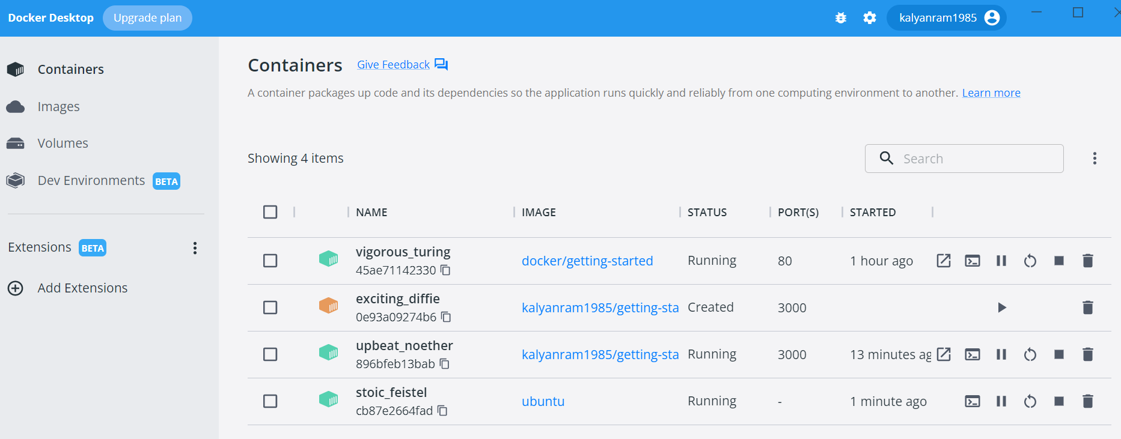

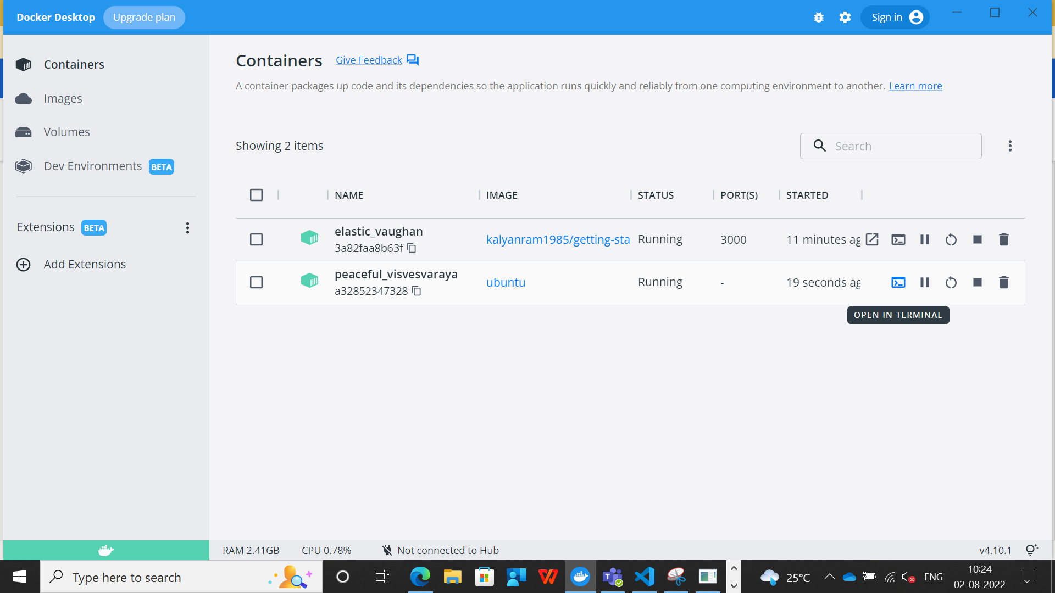

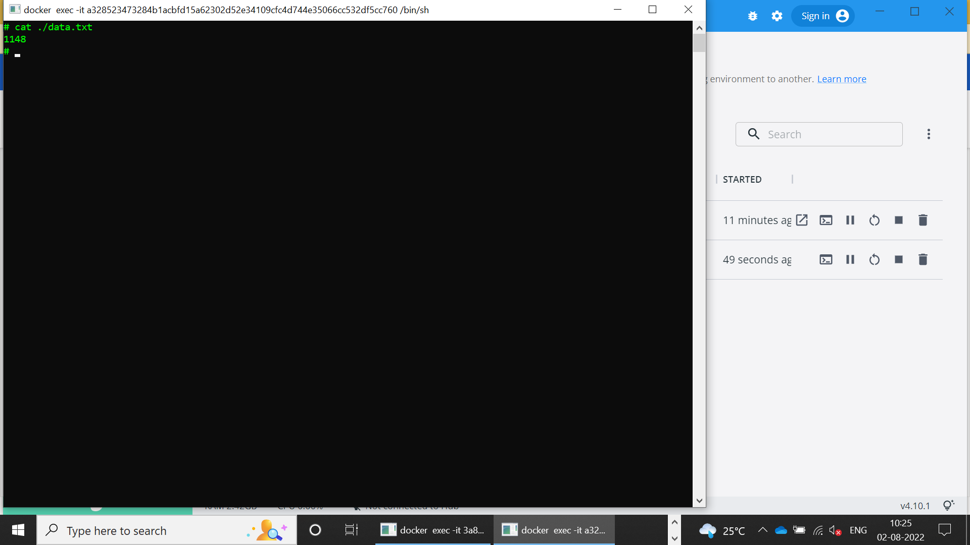





Go ahead and remove the first container using the docker rm -f <container-id> command.



Persist the todo data

Create a volume by using the docker volume create command.



Stop and remove the todo app container once again in the Dashboard



Start the todo app container



Once the container starts up, open the app and add a few items to your todo list.

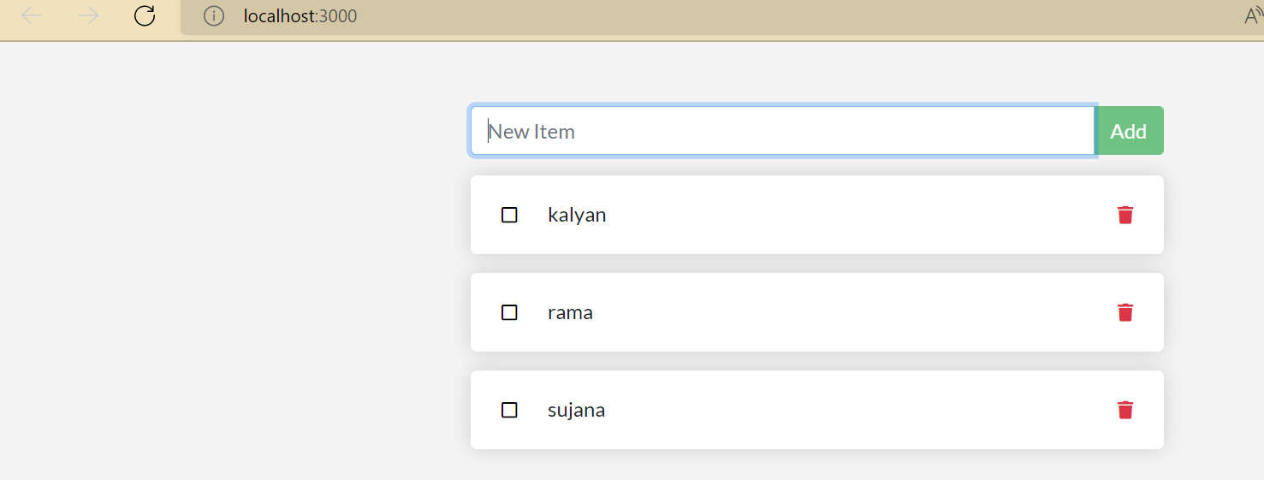



Stop and remove the container for the todo app. Use the Dashboard or docker ps to get the ID and then docker rm -f <id> to remove it.

Start a new container using the same command from above.

Open the app and see items still in list!

Go ahead and remove the container when you’re done checking out your list.

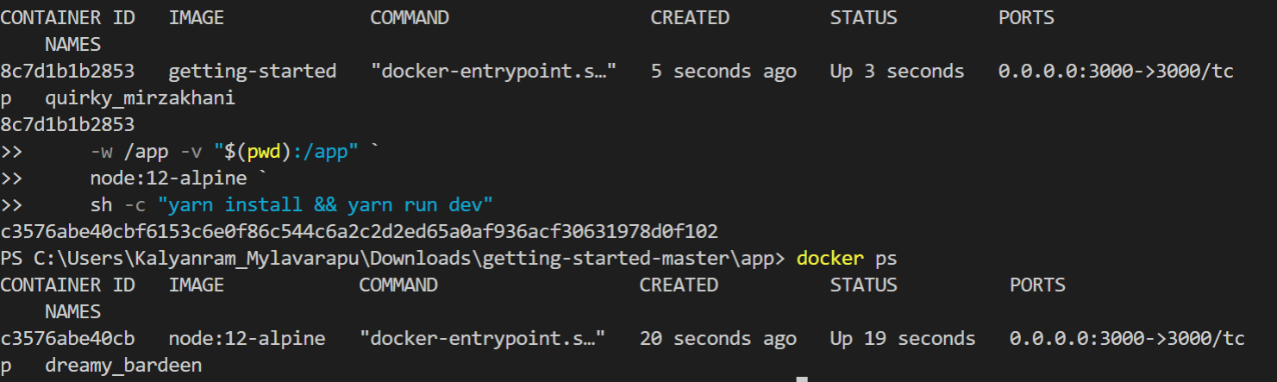

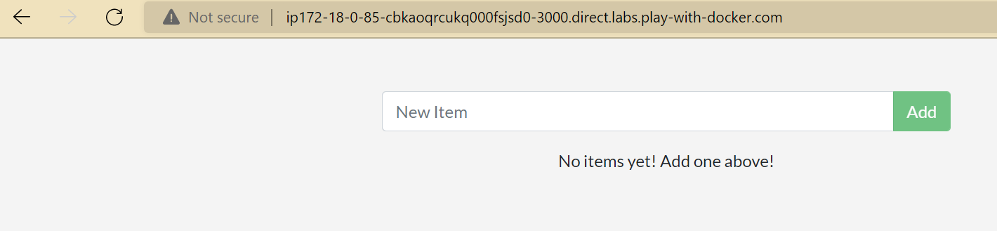

* **Use bind mounts**

Start a dev-mode container

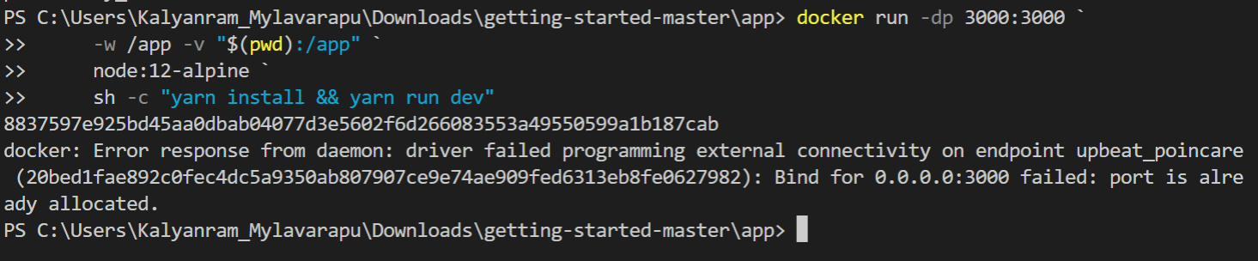

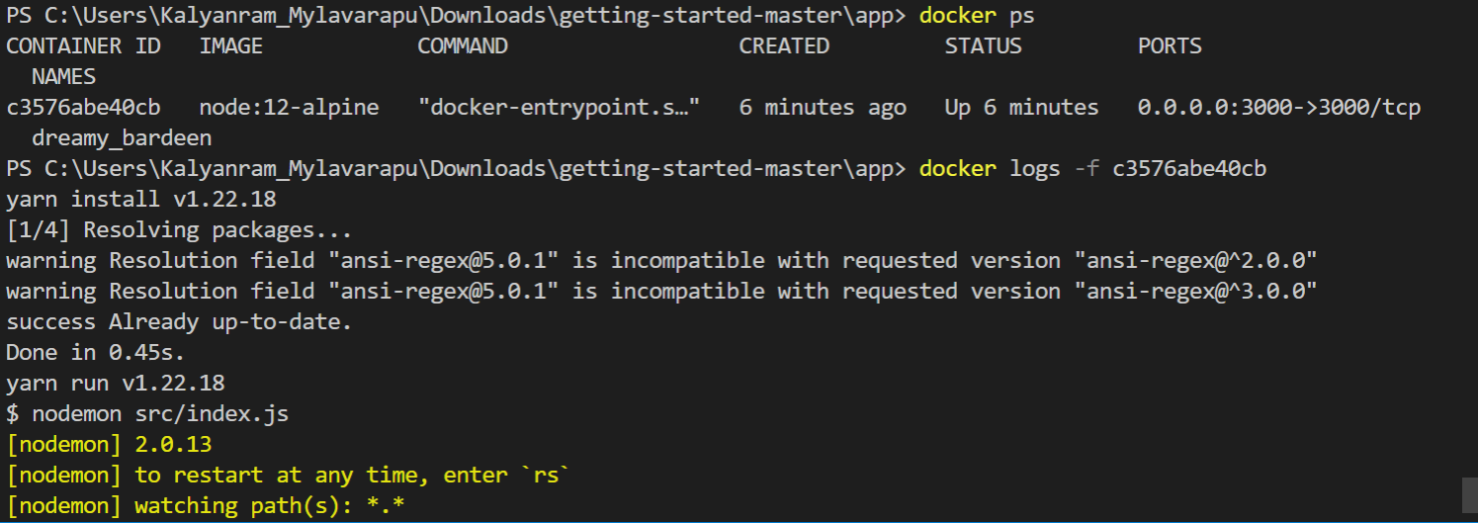

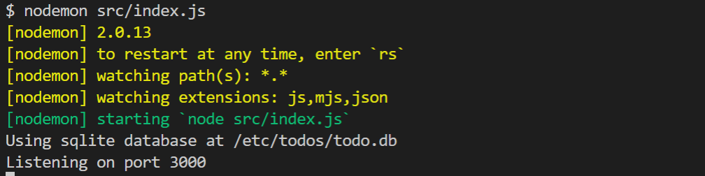

Now, let’s make a change to the app. In the src/static/js/app.js file, let’s change the “Add Item” button to simply say “Add”. This change will be on line 109:

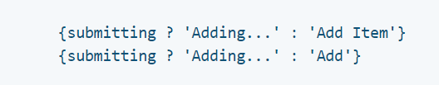

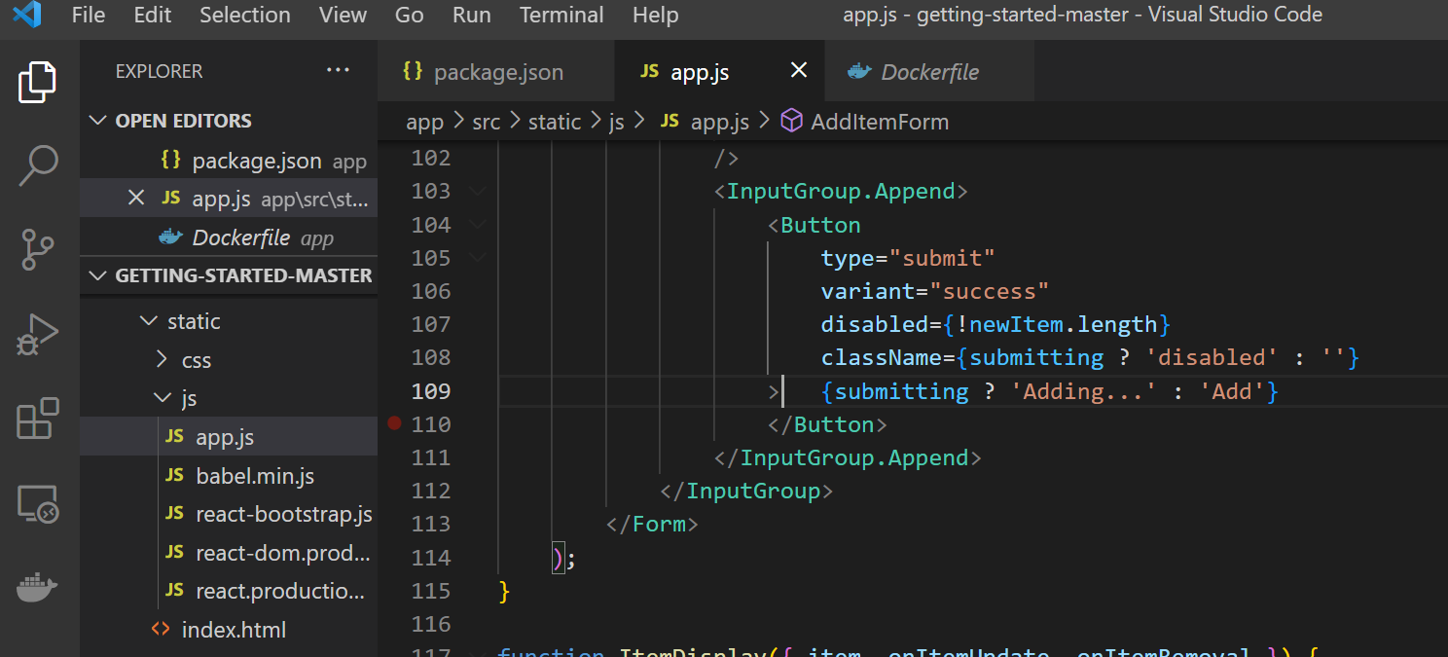

Simply refresh the page (or open it)

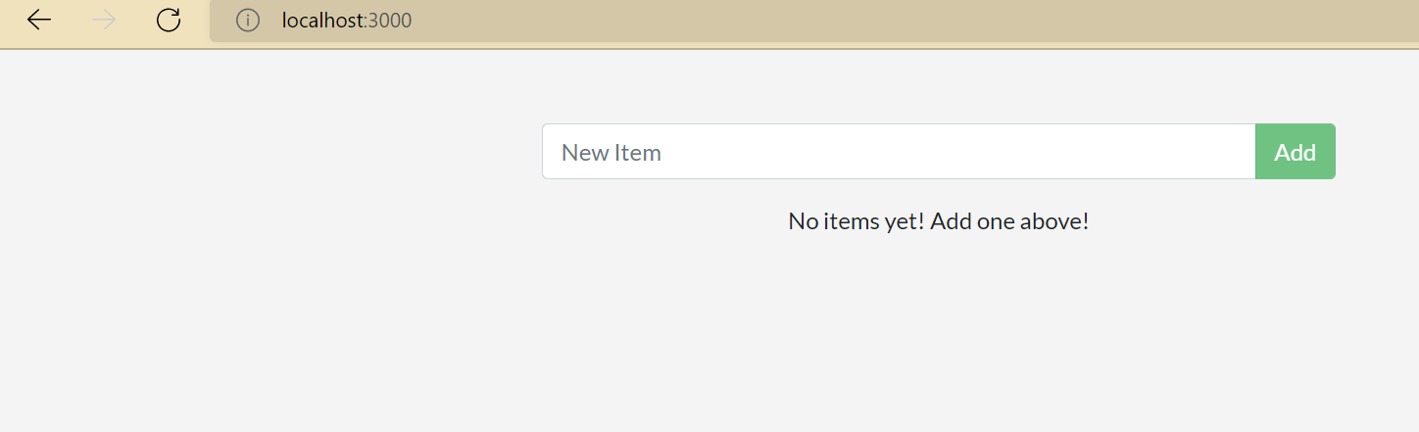

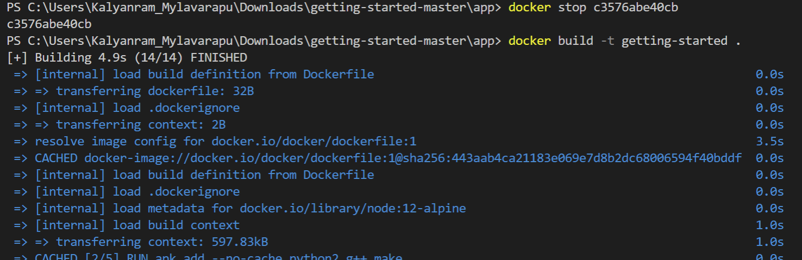

* **Multi container apps**

Start MySQL

1.Create the network.

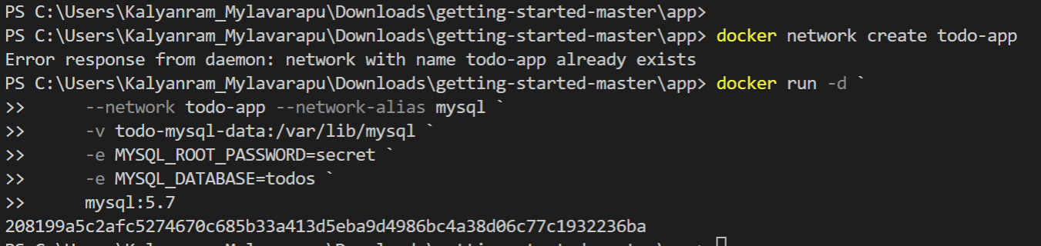

2.To confirm we have the database up and running, connect to the database and verify it connects.

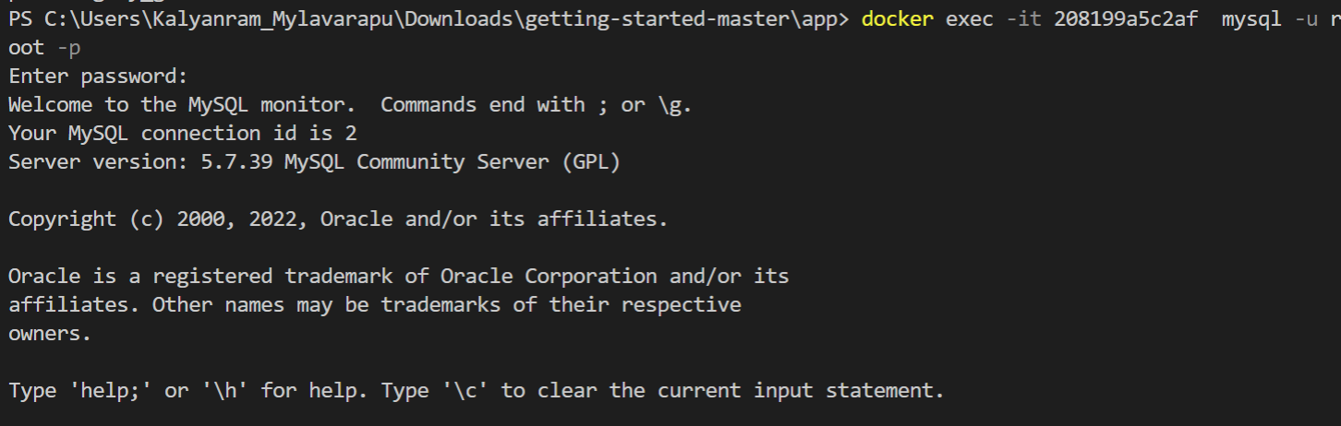

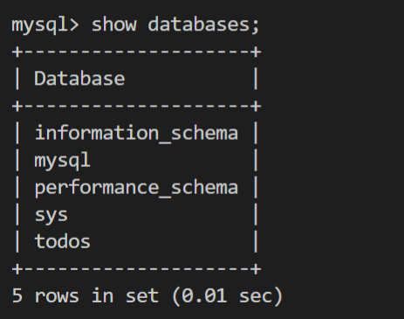

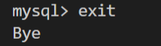

Connect to MySQL

Start a new container using the nicolaka/netshoot image. Make sure to connect it to the same network.

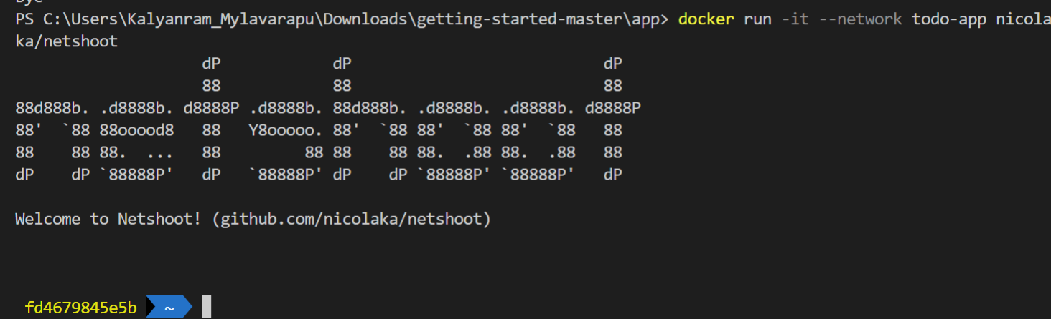

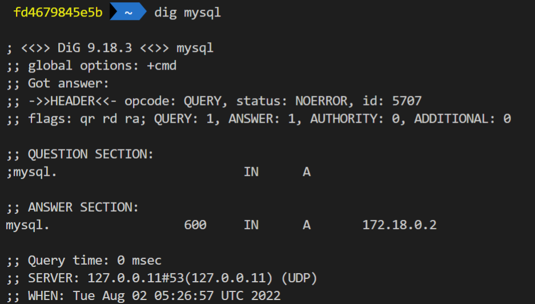

Run your app with MySQL

* **Use Docker Compose**

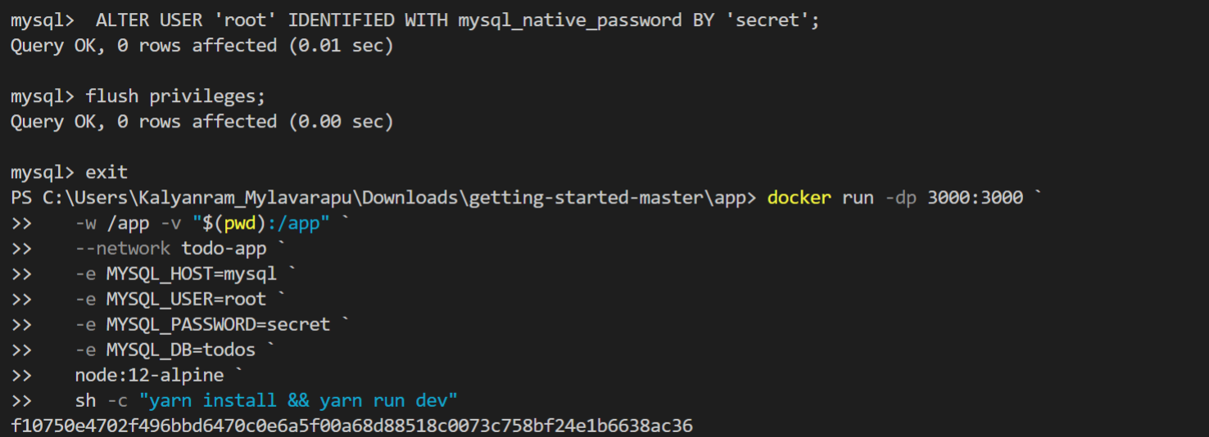

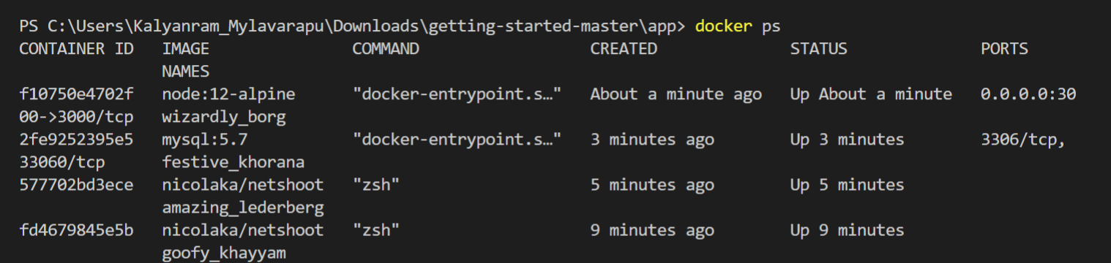

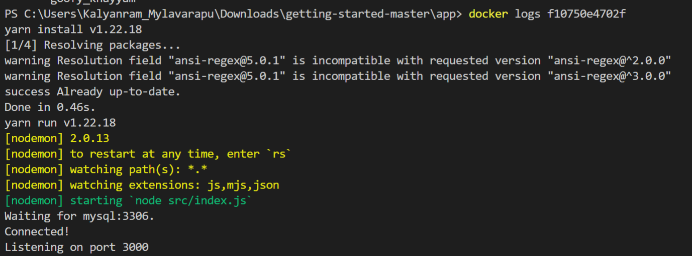

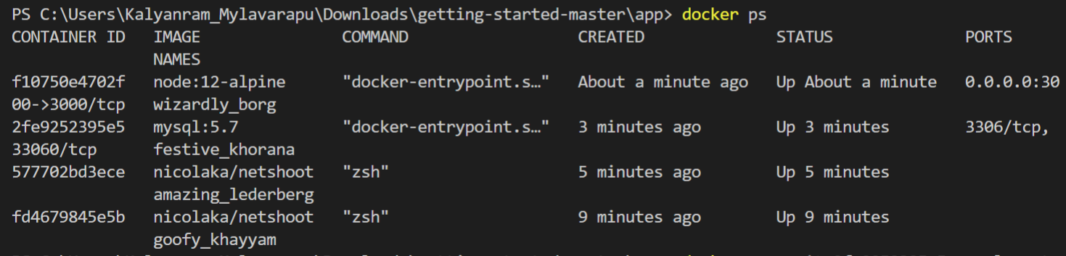

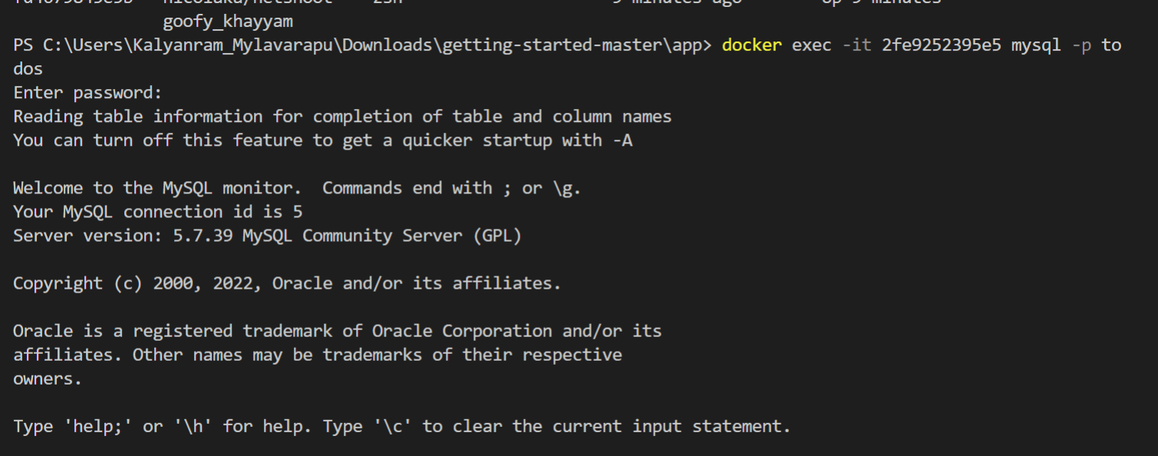

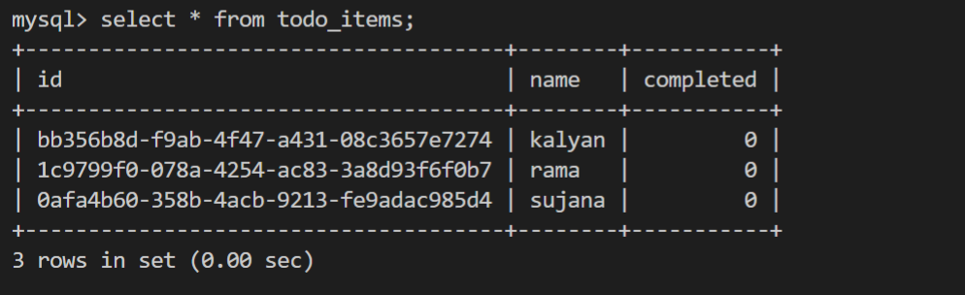

**1b) Three Tier web application using Kubernetes**

**Steps:**

1.Open the cloud guru and select Playground. Then display the following screenshot.

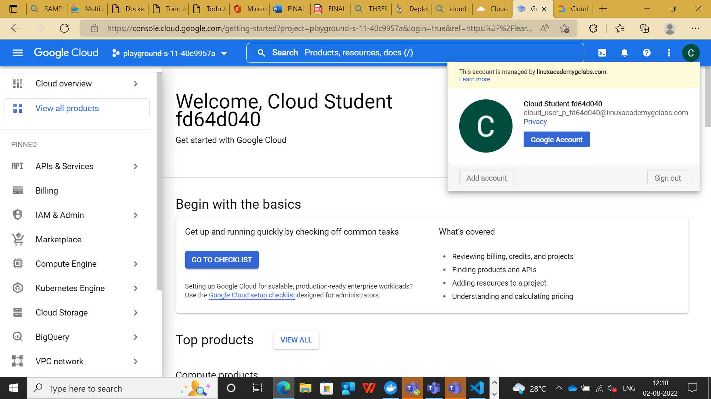

2.After that select the Kubernetes Engine, then display the following screen.

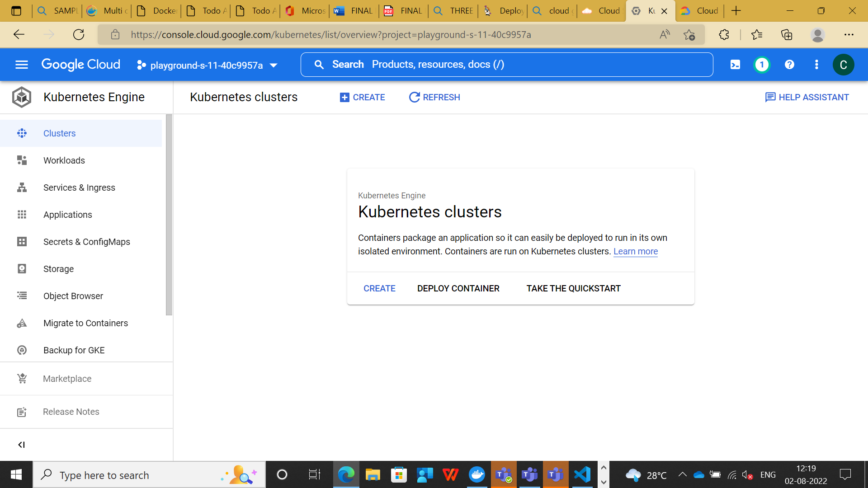

3.Then select cluster button for creating a cluster. Then find the below screen.

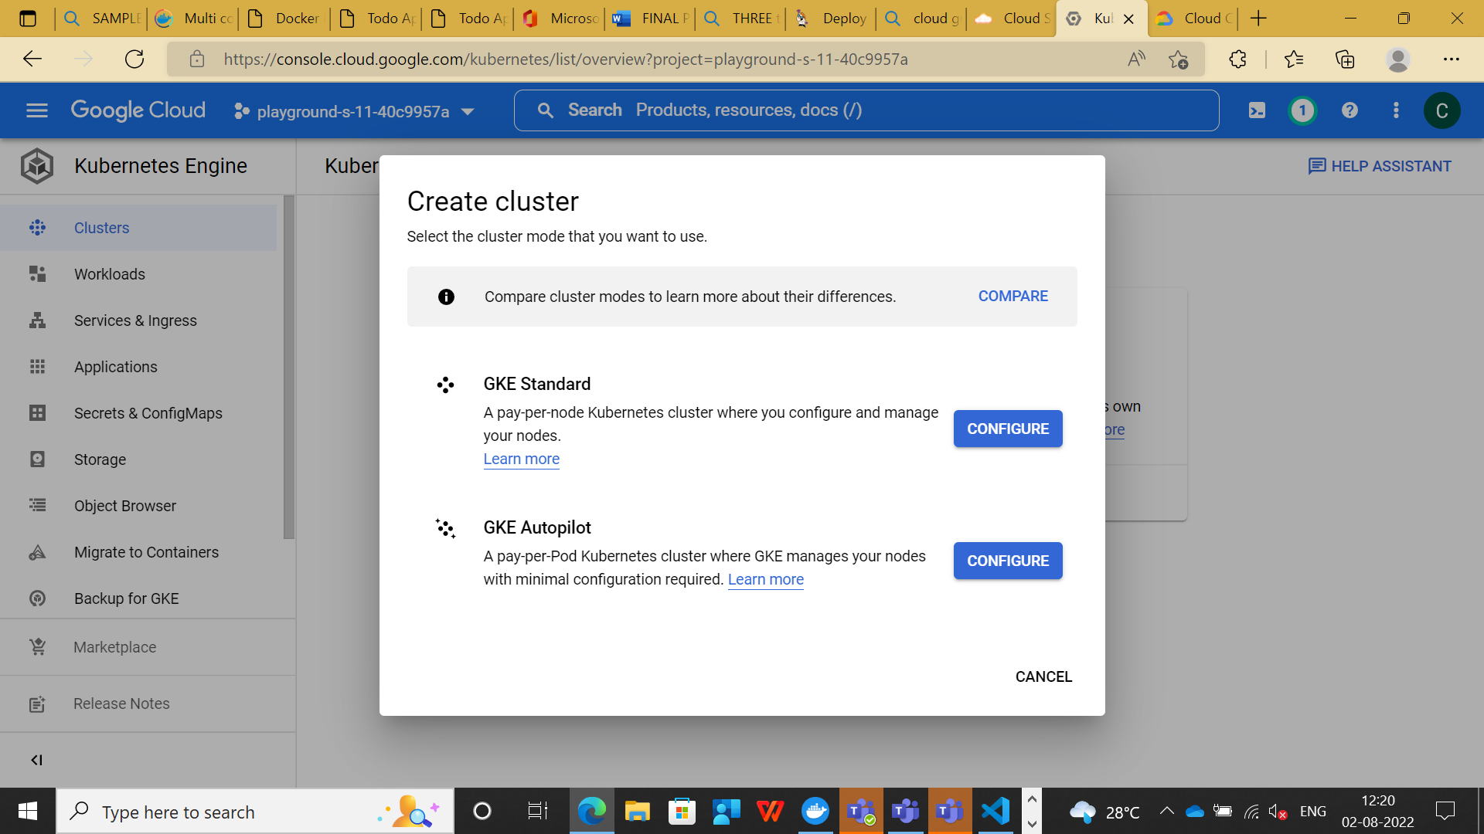

4.Select the GKE Started configuring button.

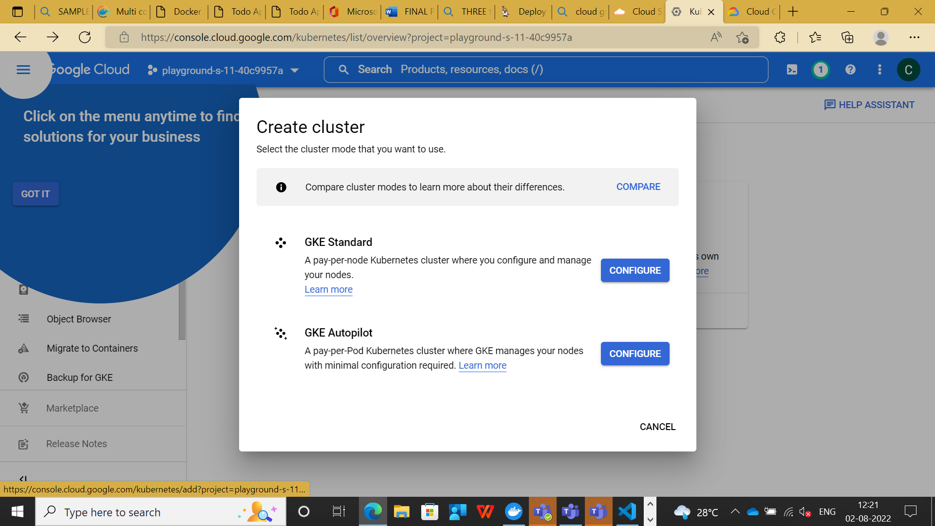

5.Then displays the Name of the cluster . Here we are giving the Name of the cluster.

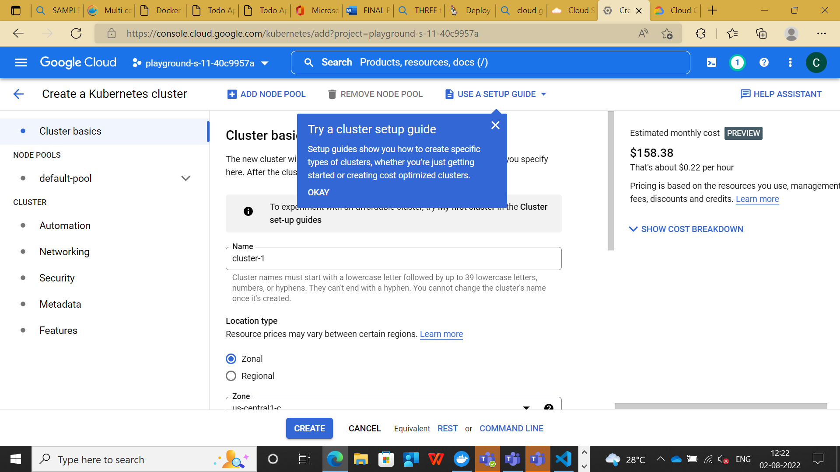

6.Then after clicking the action button.

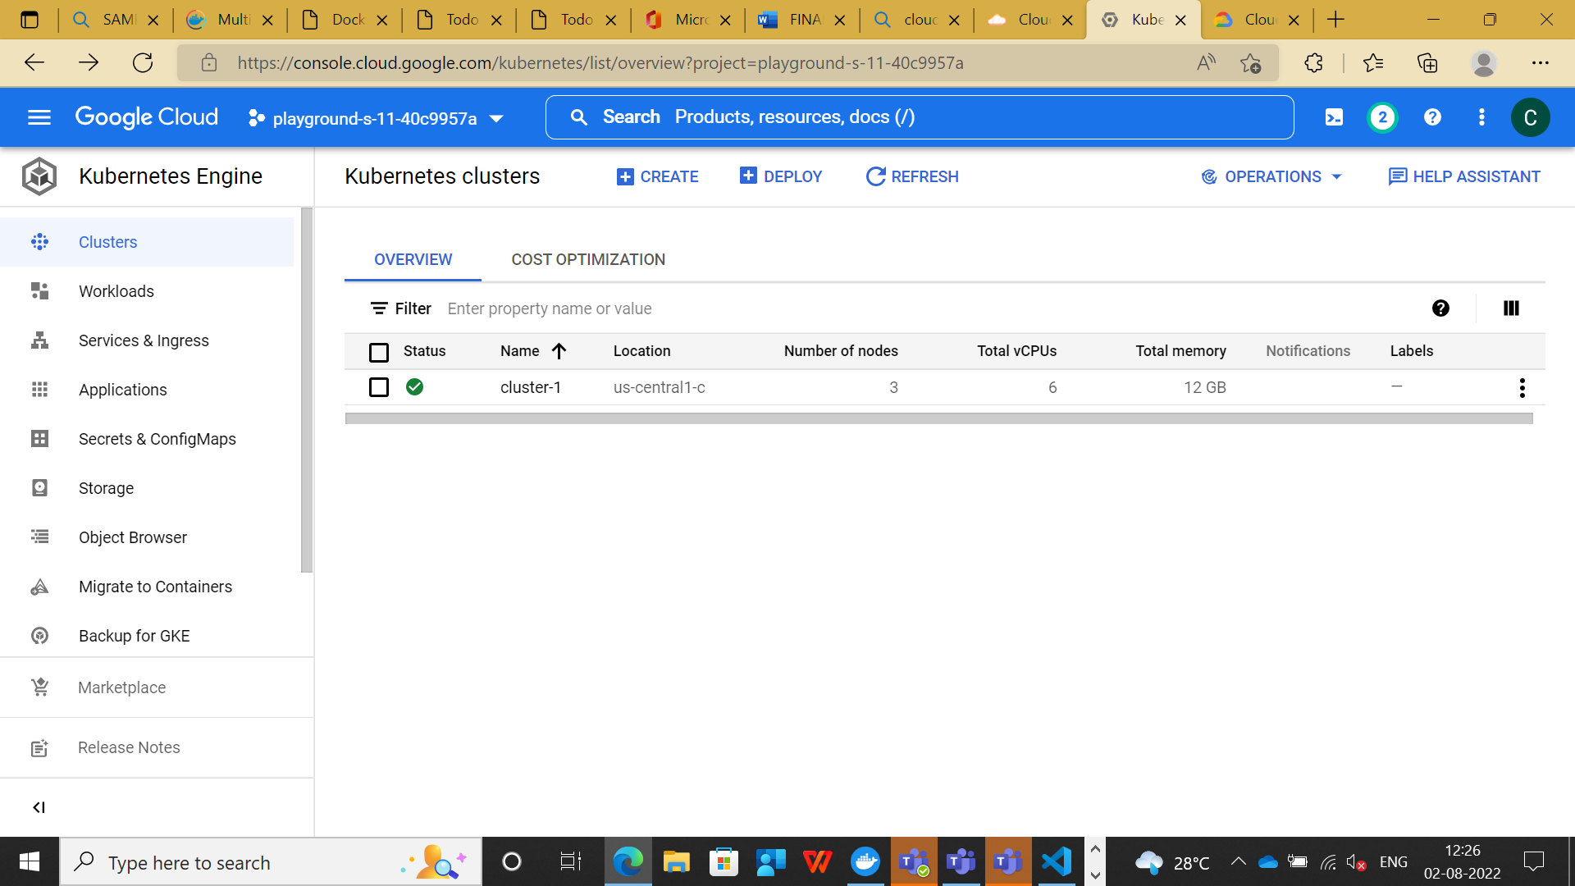

7.Select the cluster and open the console, run the below commands.

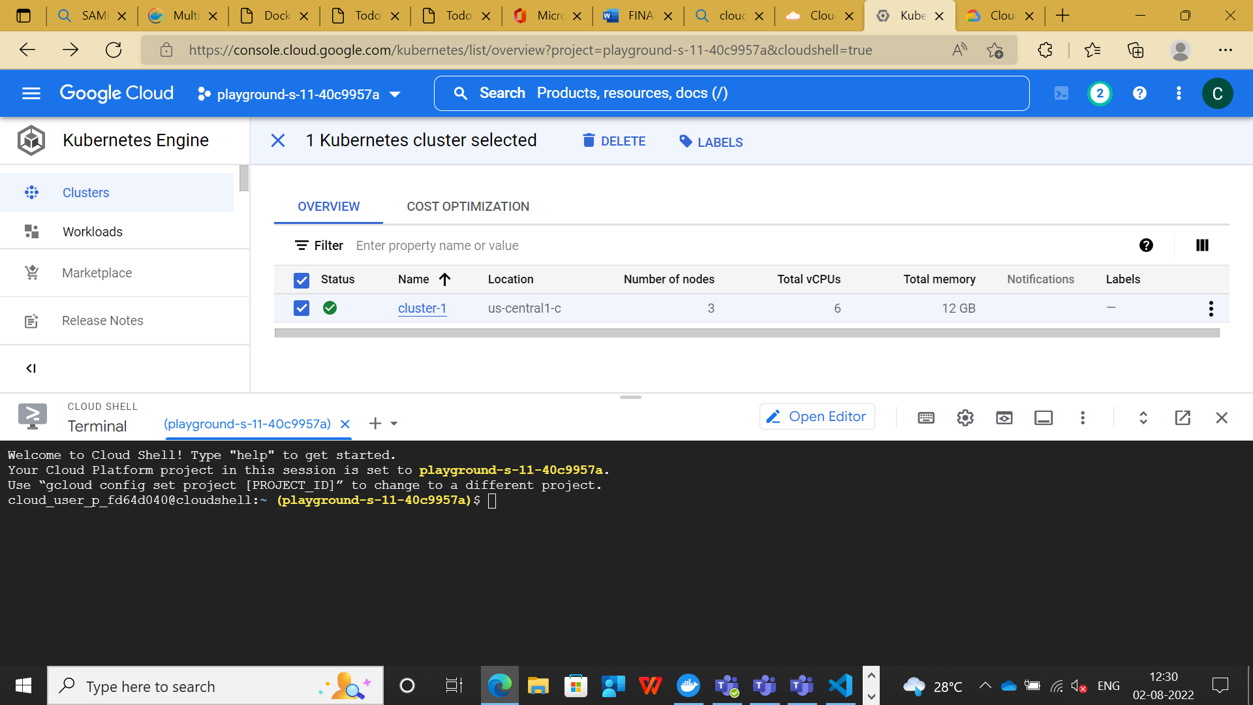

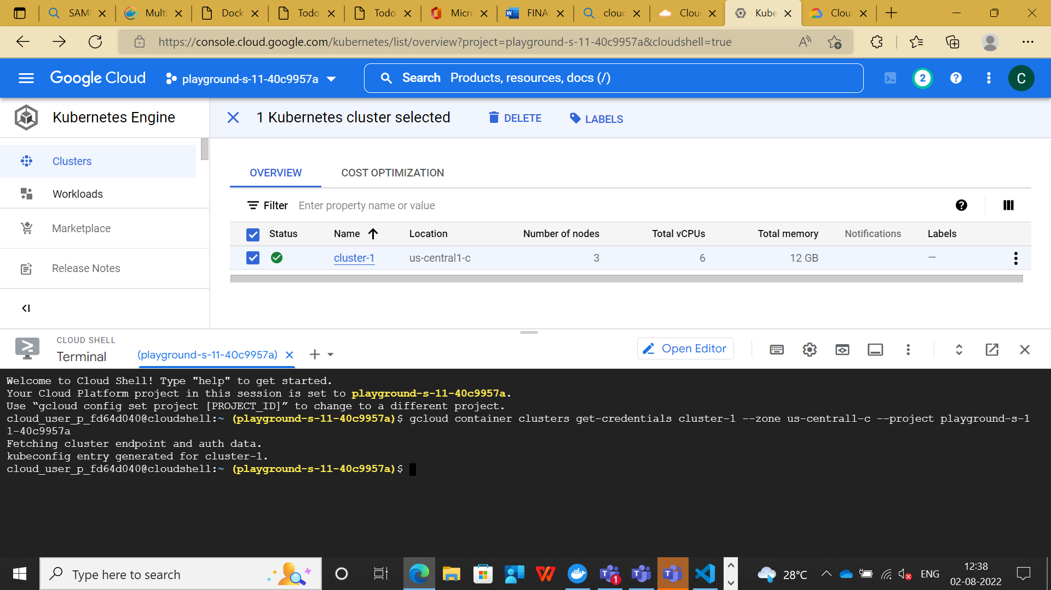

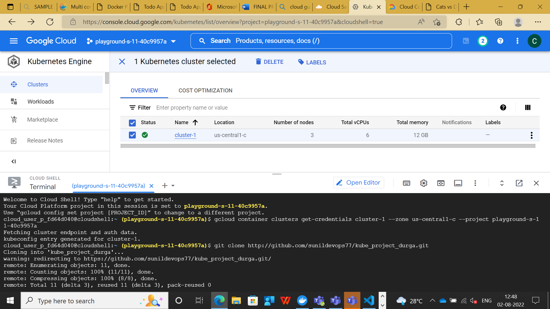

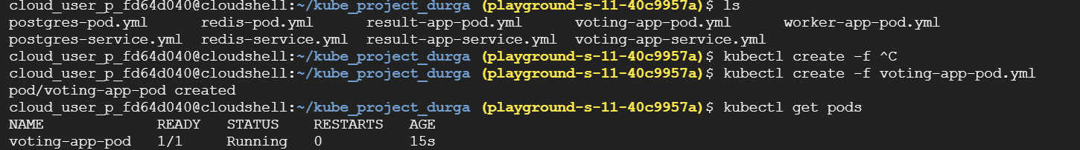

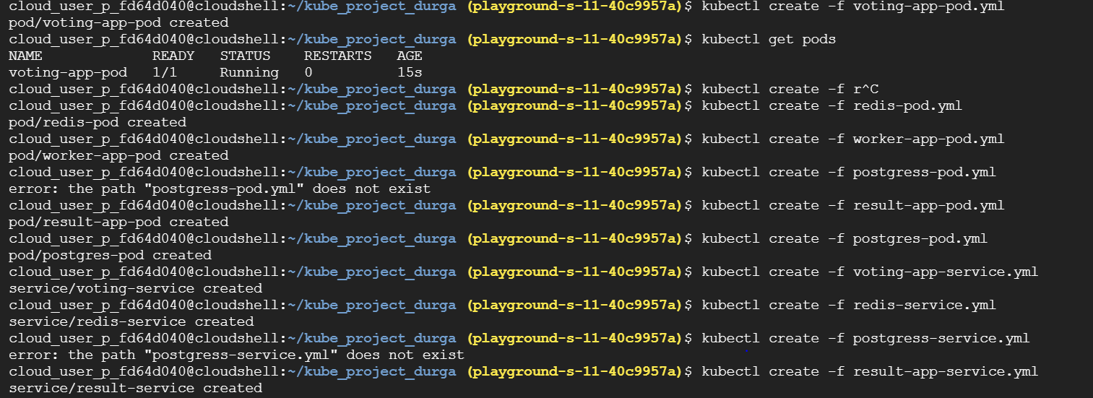

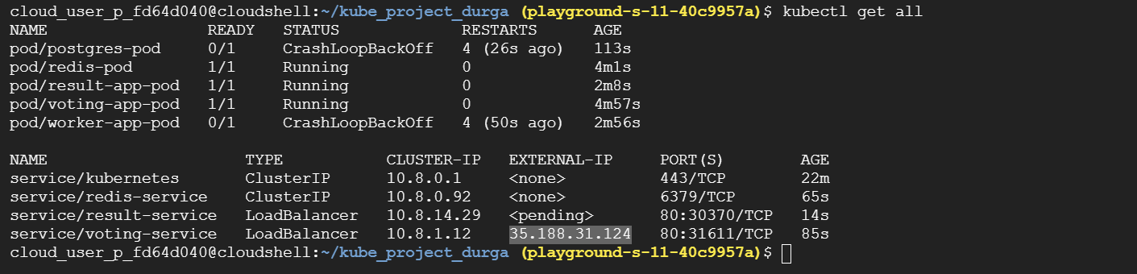

8.Here select the web application voting-service ip number and run in the browser.

